DBMS Project



**Hospital Management System**

Submitted to: Dr.Sanjeev Rao

Gurjot Singh 102103173

Mayank Chopra 102103158

**INDEX**

1. Problem statement
2. Overview
3. Requirement Analysis
4. ER Diagram
5. ER to Table
6. Normalisation
7. Functional Dependencies
8. Code and Output

**Problem Statement**

Developing a hospital management system in order to effectively manage most aspects of hospitals such as booking appointments, managing patient records and keeping medical report.

**Overview**

The hospital is a multi-specialty facility that provides a wide range of healthcare services, including inpatient care, outpatient care, surgeries, diagnostics, and pharmacy services. The hospital has multiple departments, such as cardiology, oncology, orthopedics, pediatrics, etc., and each department has its own team of doctors, nurses, and support staff. Hence it is very important for a hospital to have a DBMS that easily allows patients to book appointments and allows doctors or administrators to manage patient data.

**Requirements Analysis**

1. Patient Management:

* Ability to add new patients with their details such as patient_id, patient_name, patient_dob, patient_gender, patient_phone, and patient_address.
* Ability to retrieve patient information based on patient_id or patient_name.
* Ability to update patient information such as patient_name, patient_dob, patient_gender, patient_phone, and patient_address.

1. Doctor Management:

* Ability to add new doctors with their details such as doctor_id, doctor_name, doctor_email, and doctor_phone.
* Ability to retrieve doctor information based on doctor_id or doctor_name.
* Ability to update doctor information such as doctor_name, doctor_email, and doctor_phone.

1. Appointment Management:

* Ability to add new appointments with their details such as appointment_id, appointment_date, patient_id, doctor_id, and appointment_reason.
* Ability to retrieve appointment information based on appointment_id, patient_id, or doctor_id.
* Ability to update appointment information such as appointment_date and appointment_reason.

1. Medical Record Management:

* Ability to add new medical records with their details such as record_id, appointment_id, record_date, and record_details.
* Ability to retrieve medical record information based on record_id or appointment_id.
* Ability to update medical record information such as record_date and record_details.

1. Error Handling:

* Ability to handle errors that may occur during data insertion, retrieval, update, or deletion.
* Display appropriate error messages when errors occur, indicating the nature of the error and possible solutions.

**ER Diagram**

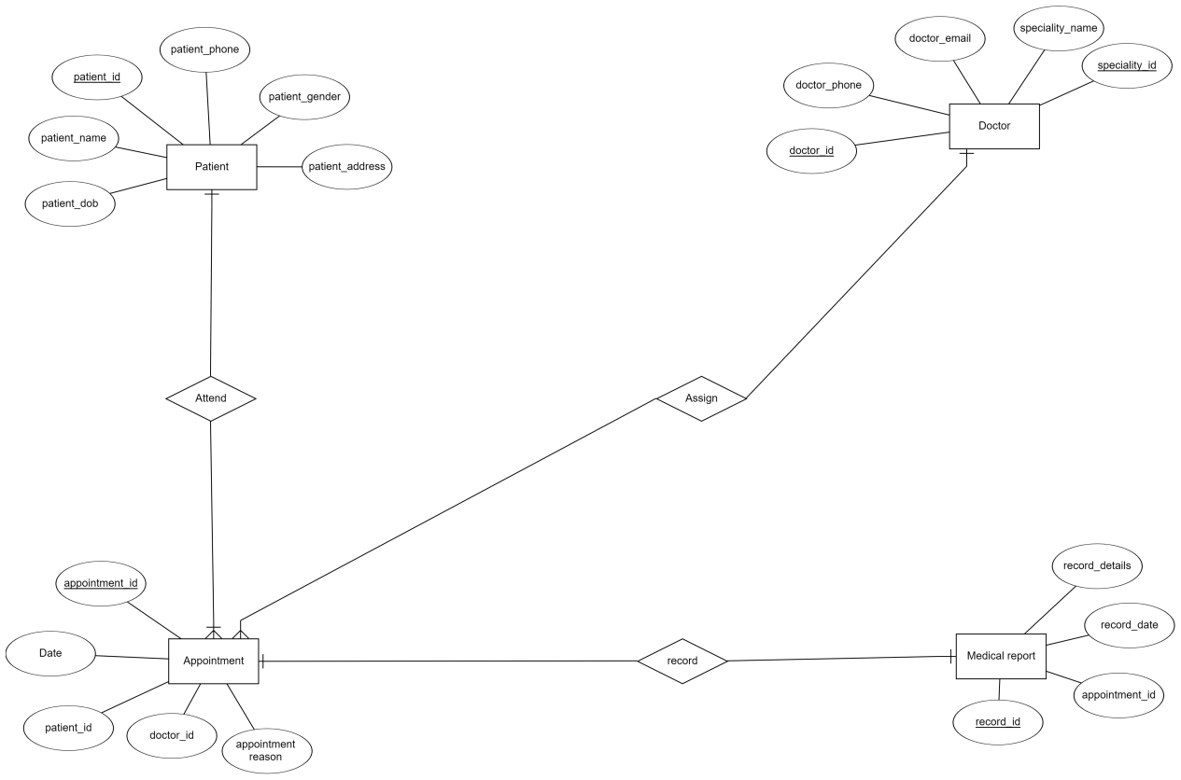

**ER Diagram To Table**

1 Patient

|  |  |  |  |  |  |
| --- | --- | --- | --- | --- | --- |
| **Pid** | name | dob | gender | address | phone |

2 Doctor

|  |  |  |  |
| --- | --- | --- | --- |
| **Did** | doctor_name | doctor_email | doctor_phone |
| **speciality_id** | speciality_name |

3 medical_records

|  |  |  |  |
| --- | --- | --- | --- |
| **Rid** | Aid | record_date | record_details |

4 Appointment

|  |  |  |  |  |
| --- | --- | --- | --- | --- |
| **Aid** | appointment_date | Pid | Did | appointment_reason |

**Normalisation**

**Relation: Attend**

**UNF:** patient_id, patient_dob, patient_name, patient_gender, patient_phone,patient_address,appointment**_**id, appointment_date, patient_id, doctor_id, appointment_reason

**2NF:**

1 **Patient** :

R = (**patient_id**, patient_dob, patient_name, patient_gender, patient_phone,patient_address)

**2 Appointment:**

R = (**appointment_id**, appointment_date, patient_id, doctor_id, appointment_reason)

Already in 3nf

**Relation: Assign**

**UNF:**doctor_id, doctor_name, doctor_email, doctor_phone,speciality_id**,** speciality_name, appointment**_**id, appointment_date, patient_id, doctor_id, appointment_reason

**2NF:**

**1 Doctor** :

R = (**doctor_id**, doctor_name, doctor_email, doctor_phone)

**2 Appointment:**

R = (**appointment_id**, appointment_date, patient_id, doctor_id, appointment_reason)

**3 specialties:**

R = (**speciality_id,** speciality_name)

**3NF:**

**1 Doctor** :

R = (**doctor_id**, doctor_name, doctor_email, doctor_phone)

**2 Appointment:**

R = (**appointment_id**, appointment_date, patient_id, doctor_id, appointment_reason)

**3 specialties:**

R = (**speciality_id,** speciality_name)

**4 doctors_specialties:**

R = (doctor_id(FK), speciality_id(FK))

**Relation: Record**

**UNF:** appointment**_**id, appointment_date, patient_id, doctor_id, appointment_reason,

record_id, appointment_id, record_date, record_details

**2 NF:**

**1 Appointment:**

R = (**appointment_id**, appointment_date, patient_id, doctor_id, appointment_reason)

**2 Medical_records** :

R = (**record_id**, appointment_id, record_date, record_details)

Already in 3nf

**Functional Dependencies:**

1. **Patient** :

R = (**patient_id**, patient_dob, patient_name, patient_gender, patient_phone,patient_address)

FDs:

1. patient_id-> patient_name
2. patient_id-> patient_dob
3. patient_id-> patient_gender
4. patient_id-> patient_phone
5. patient_id->patient_address
6. **medical_records** :

R = (**record_id**, appointment_id, record_date, record_details)

FDs:

1. record_id-> record_date
2. record_id-> record_details
3. record_id-> appointment_id
4. **Doctor** :

R = (**doctor_id**, doctor_name, doctor_email, doctor_phone)

FDs:

1. doctor_id-> doctor_name
2. doctor_id-> doctor_email
3. doctor_id-> doctor_phone
4. **Appointment:**

R = (**appointment_id**, appointment_date, patient_id, doctor_id, appointment_reason)

FDs:

1. appointment_id-> appointment_date
2. appointment_id-> patient_id
3. appointment_id->doctor_id
4. appointment_id-> appointment_reason
5. **doctors_specialities:**

R = (**doctor_id, speciality_id**)

Since entire table is the key, it does not have partial and transitive dependencies. It also has atomic attributes.

1. **specialities:**

R = (**speciality_id,** speciality_name)

1. **speciality_id**-> speciality_name

**Final Database After Normalization**

1 Patient

|  |  |  |  |  |  |
| --- | --- | --- | --- | --- | --- |
| **Pid** | name | dob | gender | address | phone |

2 Doctor

|  |  |  |  |
| --- | --- | --- | --- |
| **Did** | doctor_name | doctor_email | doctor_phone |

3 medical_records

|  |  |  |  |
| --- | --- | --- | --- |
| **Rid** | Aid | record_date | record_details |

4 Appointment

|  |  |  |  |  |
| --- | --- | --- | --- | --- |
| **Aid** | appointment_date | Pid | Did | appointment_reason |

5 doctors_specialties

|  |  |
| --- | --- |
| Did | Pid |

6 specialties

|  |  |
| --- | --- |
| **speciality_id** | speciality_name |

**Code For Creation of Tables**

CREATE TABLE patients (

patient_id INT PRIMARY KEY,

patient_name VARCHAR2(50),

patient_dob DATE,

patient_gender CHAR(1),

patient_phone VARCHAR2(20),

patient_address VARCHAR2(100)

);

CREATE TABLE doctors (

doctor_id INT PRIMARY KEY,

doctor_name VARCHAR2(50),

doctor_email VARCHAR2(50),

doctor_phone VARCHAR2(20)

);

CREATE TABLE specialities (

speciality_id INT PRIMARY KEY,

speciality_name VARCHAR2(50)

);

CREATE TABLE doctors_specialities (

doctor_id INT,

speciality_id INT,

FOREIGN KEY (doctor_id) REFERENCES doctors(doctor_id),

FOREIGN KEY (speciality_id) REFERENCES specialities(speciality_id)

);

CREATE TABLE appointments (

appointment_id INT PRIMARY KEY,

appointment_date DATE,

patient_id INT,

doctor_id INT,

appointment_reason VARCHAR2(100),

CONSTRAINT fk_patient FOREIGN KEY (patient_id) REFERENCES patients(patient_id),

CONSTRAINT fk_doctor FOREIGN KEY (doctor_id) REFERENCES doctors(doctor_id)

);

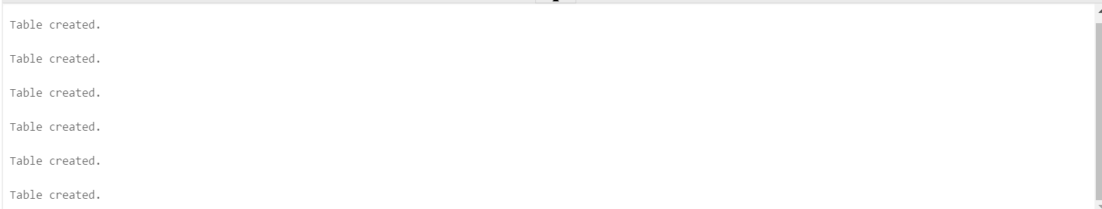

**Procedure To insert values into tables**

-- To add a patient

CREATE OR REPLACE PROCEDURE add_patient (

p_patient_id IN patients.patient_id%TYPE,

p_patient_name IN patients.patient_name%TYPE,

p_patient_dob IN patients.patient_dob%TYPE,

p_patient_gender IN patients.patient_gender%TYPE,

p_patient_phone IN patients.patient_phone%TYPE,

p_patient_address IN patients.patient_address%TYPE

)

IS

BEGIN

INSERT INTO patients (

patient_id,

patient_name,

patient_dob,

patient_gender,

patient_phone,

patient_address

) VALUES (

p_patient_id,

p_patient_name,

p_patient_dob,

p_patient_gender,

p_patient_phone,

p_patient_address

);

COMMIT;

END;

/

-- TO add doctor

CREATE OR REPLACE PROCEDURE add_doctor(

p_doctor_id IN doctors.doctor_id%TYPE,

p_doctor_name IN doctors.doctor_name%TYPE,

p_doctor_email IN doctors.doctor_email%TYPE,

p_doctor_phone IN doctors.doctor_phone%TYPE

)

IS

BEGIN

INSERT INTO doctors(doctor_id, doctor_name, doctor_email, doctor_phone)

VALUES(p_doctor_id, p_doctor_name, p_doctor_email, p_doctor_phone);

COMMIT;

dbms_output.put_line('Doctor added successfully');

EXCEPTION

WHEN OTHERS THEN

dbms_output.put_line('Error occurred while adding doctor: ' || SQLERRM);

END;

/

-- To add Specialities

CREATE OR REPLACE PROCEDURE add_speciality(

p_speciality_id IN specialities.speciality_id%TYPE,

p_speciality_name IN specialities.speciality_name%TYPE

)

IS

BEGIN

-- insert the new speciality into the table

INSERT INTO specialities(speciality_id, speciality_name)

VALUES(p_speciality_id, p_speciality_name);

DBMS_OUTPUT.PUT_LINE('Speciality added successfully');

EXCEPTION

WHEN OTHERS THEN

DBMS_OUTPUT.PUT_LINE('Error adding speciality: ' || SQLERRM);

END;

/

--to add doctor_specilisation

CREATE OR REPLACE PROCEDURE add_doctor_speciality(p_doctor_id IN INT, p_speciality_id IN INT)

IS

BEGIN

INSERT INTO doctors_specialities(doctor_id, speciality_id)

VALUES (p_doctor_id, p_speciality_id);

COMMIT;

DBMS_OUTPUT.PUT_LINE('Doctor speciality added successfully.');

EXCEPTION

WHEN OTHERS THEN

ROLLBACK;

DBMS_OUTPUT.PUT_LINE('Error adding doctor speciality: ' || SQLERRM);

END;

/

-- Add an appointment

CREATE OR REPLACE PROCEDURE add_appointment (

p_appointment_id IN appointments.appointment_id%TYPE,

p_appointment_date IN appointments.appointment_date%TYPE,

p_patient_id IN appointments.patient_id%TYPE,

p_doctor_id IN appointments.doctor_id%TYPE,

p_appointment_reason IN appointments.appointment_reason%TYPE

)

IS

BEGIN

-- Insert appointment

INSERT INTO appointments (appointment_id, appointment_date, patient_id, doctor_id, appointment_reason)

VALUES (p_appointment_id, p_appointment_date, p_patient_id, p_doctor_id, p_appointment_reason);

-- Commit the changes

COMMIT;

-- Display a message indicating successful insertion

DBMS_OUTPUT.PUT_LINE('Appointment added successfully!');

EXCEPTION

WHEN OTHERS THEN

-- Display an error message if an exception occurs

DBMS_OUTPUT.PUT_LINE('Error: ' || SQLERRM);

ROLLBACK;

END;

/

-- To add Medical_record

CREATE OR REPLACE PROCEDURE add_medical_report (

p_record_id IN medical_report.record_id%TYPE,

p_appointment_id IN medical_report.appointment_id%TYPE,

p_record_date IN medical_report.record_date%TYPE,

p_record_details IN medical_report.record_details%TYPE

)

IS

BEGIN

-- Insert medical record

INSERT INTO medical_report (record_id, appointment_id, record_date, record_details)

VALUES (p_record_id, p_appointment_id, p_record_date, p_record_details);

-- Commit the changes

COMMIT;

-- Display a message indicating successful insertion

DBMS_OUTPUT.PUT_LINE('Medical report added successfully!');

EXCEPTION

WHEN OTHERS THEN

-- Display an error message if an exception occurs

DBMS_OUTPUT.PUT_LINE('Error: ' || SQLERRM);

ROLLBACK;

END;

/

BEGIN

add_patient(1,'Mahesh','11-FEB-2000','M','7589461236','Mohali');

add_patient(2,'Suresh','10-JAN-1998','M','5896412368','Patiala');

add_patient(3,'Sheela','01-NOV-2002','F','6258974131','Lucknow') ;

add_doctor(1, 'Dr. John Doe', 'john.doe@example.com', '555-555-1234');

add_doctor(2,'Himesh','himesh1@gmail.com','8974561256');

add_doctor(3,'Sonia','soni5@gmail.com','9658741288') ;

add_speciality(1,'Cardiology');

add_speciality(2,'ENT');

add_speciality(3,'Brain');

add_doctor_speciality(1, 1);

-- Adding doctor with doctor_id = 1 to speciality with speciality_id = 1

add_doctor_speciality(2, 3);

add_doctor_speciality(3, 2);

add_appointment(1, '01-JAN-2023', 1, 1, 'Follow-up appointment');

add_medical_report( 1,1,TO_DATE('2023-04-16', 'YYYY-MM-DD'),'Patient had a check-up, prescribed medication for common cold.');

select * from patients;

select * from doctors;

select * from specialities;

select * from doctors_specialities;

select * from appointments;

select * from medical_report;

END;

/

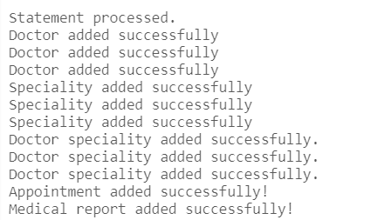

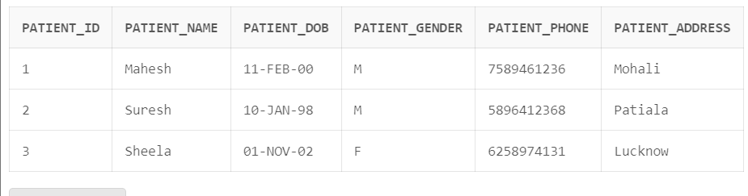

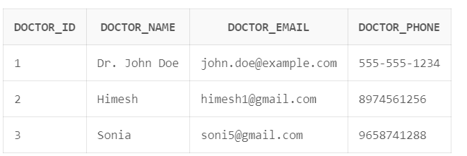

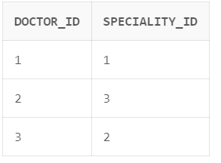

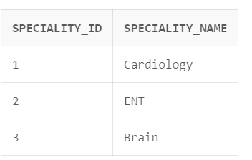

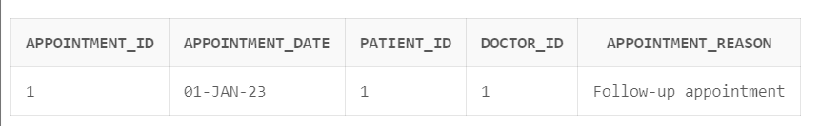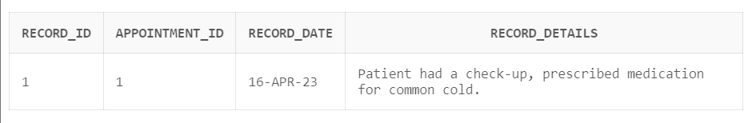

**Function to Get Doctor name From Specialization name**

CREATE OR REPLACE FUNCTION get_doctor_name_from_specialization(p_specialization_name IN VARCHAR2)

RETURN VARCHAR2

IS

v_doctor_name doctors.doctor_name%TYPE;

BEGIN

SELECT d.doctor_name

INTO v_doctor_name

FROM doctors d

INNER JOIN doctors_specialities ds ON d.doctor_id = ds.doctor_id

INNER JOIN specialities s ON ds.speciality_id = s.speciality_id

WHERE s.speciality_name = p_specialization_name;

RETURN v_doctor_name;

EXCEPTION

WHEN NO_DATA_FOUND THEN

RETURN NULL;

WHEN OTHERS THEN

RAISE;

END;

/

DECLARE

v_doctor_name doctors.doctor_name%TYPE;

BEGIN

v_doctor_name := get_doctor_name_from_specialization('Cardiology');

IF v_doctor_name IS NOT NULL THEN

DBMS_OUTPUT.PUT_LINE('Doctor Name: ' || v_doctor_name);

ELSE

DBMS_OUTPUT.PUT_LINE('No doctor found for the given specialization name.');

END IF;

END;

/

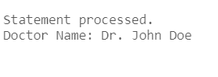

**Function to retrieve medical_report from appointment_Id**

CREATE OR REPLACE FUNCTION get_medical_record(p_appointment_id IN appointments.appointment_id%TYPE)

RETURN medical_report%ROWTYPE

IS

v_medical_record medical_report%ROWTYPE;

BEGIN

-- Query the medical_report table for the given appointment ID

SELECT *

INTO v_medical_record

FROM medical_report

WHERE appointment_id = p_appointment_id;

RETURN v_medical_record;

EXCEPTION

WHEN NO_DATA_FOUND THEN

-- Handle the case when no medical record is found for the given appointment ID

RAISE_APPLICATION_ERROR(-20001, 'Medical record not found for the given appointment ID');

END;

/

DECLARE

v_medical_record medical_report%ROWTYPE;

BEGIN

-- Call the function to get the medical record for appointment ID 12345

v_medical_record := get_medical_record(1);

-- Display the medical record details

DBMS_OUTPUT.PUT_LINE('Record ID: ' || v_medical_record.record_id);

DBMS_OUTPUT.PUT_LINE('Appointment ID: ' || v_medical_record.appointment_id);

DBMS_OUTPUT.PUT_LINE('Record Date: ' || v_medical_record.record_date);

DBMS_OUTPUT.PUT_LINE('Record Details: ' || v_medical_record.record_details);

EXCEPTION

WHEN OTHERS THEN

-- Handle any exceptions that may occur

DBMS_OUTPUT.PUT_LINE('Error: ' || SQLERRM);

END;

/

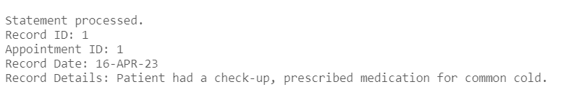

**Trigger to check slot before booking appointment**

CREATE OR REPLACE TRIGGER check_appointment

BEFORE INSERT ON appointments

FOR EACH ROW

DECLARE

count_appt NUMBER;

BEGIN

SELECT COUNT(*) INTO count_appt

FROM appointments

WHERE patient_id = :new.patient_id

AND doctor_id = :new.doctor_id

AND TRUNC(appointment_date) = TRUNC(:new.appointment_date);

IF count_appt > 0 THEN

RAISE_APPLICATION_ERROR(-20001, 'Patient has already booked an appointment with the same doctor on the same day.');

END IF;

END;

/

insert into appointments values(1, '01-JAN-2023', 1, 1, 'Follow-up appointment');

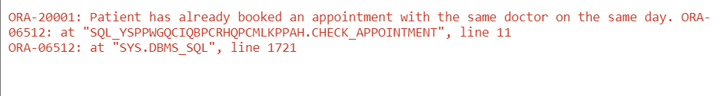

**References**

www.youtube.com/parteekBhatia

**Conclusion**

In conclusion, the healthcare management system project requires the development of a relational database management system (DBMS) that can efficiently store and manage patient information, doctor information, appointments, and medical reports. The system should be able to enforce referential integrity, perform CRUD operations, and provide appropriate error handling, data validation, and data integrity checks.